Mini project

Winter semester 22

Relationship between

morphological changes and

Cod (Gadus morha) CPUE in

Western Baltic Sea

course instructor :

Prof. Dr. Christian Möllmann

Author :

Amirhossein Feiz

[emier.fman1997@gmail.com](mailto:emier.fman1997@gmail.com)

**S5 WiSe2021**

Introduction

Fish morphological changes and capture for a given amount of effort could be related (CPUE). Yet, the kind of the morphological alteration and the fishes' habitat both play a role in this association. For instance, if a fish population suffers changes in body size or form as a result of environmental conditions like temperature changes or changes in the availability of food, it may have an impact on their swimming speed, capacity to obtain prey, or capacity to evade predators. Moreover, fish's catchability and sensitivity to fishing gear may be affected if they undergo morphological changes as a result of overfishing or selective harvesting. CPUE is a sophisticated statistic that is affected by a variety of variables, such as fishing effort, gear selection, and environmental conditions.Therefore, it would require careful examination and analysis to determine the specific nature of the relationship.((Biro & Post, 2008; Cunningham et al., 2018; Jørgensen & Fiksen, 2006; Law, 2000))

The decline in Gadus morhua (Atlantic cod) catch per unit effort (CPUE) in the western Baltic Sea is due to several factors, such as overfishing, changes in environmental conditions, and disease outbreaks. Overfishing is a major threat to the sustainability of Atlantic cod populations worldwide, and in this region, it has reduced the abundance of cod. Environmental conditions, such as temperature and salinity, can also affect the distribution and abundance of Atlantic cod, leading to lower CPUE if fishing effort is not adjusted to account for these changes. Other factors may contribute to the decline in CPUE in the western Baltic Sea, and understanding the complex interactions between fishing pressure, environmental conditions, and other factors is important for developing effective management strategies.((Casini et al., 2016; Du & Em, n.d.; Köster et al., 2005; Pulkkinen et al., 2010))

The mean length of Gadus morhua (Atlantic cod) in the Western Baltic Sea has decreased significantly in recent years, likely due to overfishing and changes in environmental conditions. A study conducted between 2003 and 2017 found that cod in the Bornholm Basin exhibited declining trends in both mean length and weight, with the most pronounced declines occurring in the early 2000s. (Vinther et al., 2018). Understanding the factors driving these changes is important for developing effective management strategies to promote the recovery and sustainability of cod populations in this region. ((Köster et al., 2017; Smoliński & Radtke, 2017))

The morphological changes of Western Baltic cod can be influenced by temperature in a number of ways, including growth rate, maturation and reproduction, muscle structure, and morphological anomalies. The exact life stage of the fish, the length and severity of temperature variations, and other environmental factors all have an impact on these outcomes. For the purpose of foreseeing and minimizing the effects of climate change on cod populations in various places, it is crucial to understand these linkages.( Brett, J. R., & Groves, T. D. D. (1979),)

Food availability can affect the morphological change of Atlantic cod in a variety of ways, such as body size, lipid content, skeletal structure, and morphological abnormalities. These effects depend on the quality, quantity, and timing of food resources, as well as the interactions between food availability and other environmental factors such as temperature and salinity. Understanding these relationships is important for predicting and mitigating the impacts of climate change and overfishing on cod populations in different regions.(15_18)

The size of a cod population or stock can affect the morphological change of individual cod in a variety of ways. These include body size, age and size structure, reproductive investment, and environmental and ecological factors. The effects of cod stock size on cod morphology are complex and depend on a variety of factors, such as density, abundance, and age structure. Understanding these relationships is important for managing and conserving cod populations in different regions.(19_21)

Materials and methods

In order to make a general view of the Western Baltic Sea Cod (Gadus morha) situation, the Cod CPUE investigated the different areas of the West Baltic (where we had related data).

In this study, fluctuations in the mean length of Western Baltic cod are considered as the morphological changes in WBC. For this purpose, we used ten different length classes in Centimeters provided by data from ICES Database. The mean in these ten length classes was evaluated over a period of 30 years to make an understanding of the decrease in WBC length.

In advance, we followed the possible reasons for this change in WBC. Three factors of Temperature, Food availability, and Cod density are considered as possible answers for the mentioned changes. A regression model of analysis was made to pursue relations between morphological changes and mentioned the factors.

In the beginning, a small number of data were used to make the following graphs about the zonation of WBC (which was possible to analyze in R software), however, for the mentioned factors over a period of 30 years we experienced a large amount of data, therefore, Python software used to fulfill the purpose.

Results

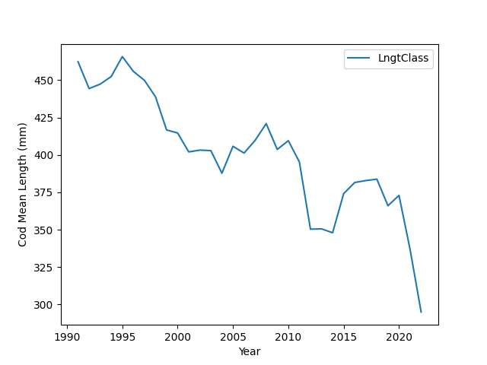

Fig.1 the bar chart shows the fluctuations of the mean length for WBC (western Baltic Cod) in a period of 32 years.

A glance at the bar chart shows Cod's significant decrease in mean length in the western Baltic Sea in recent years.

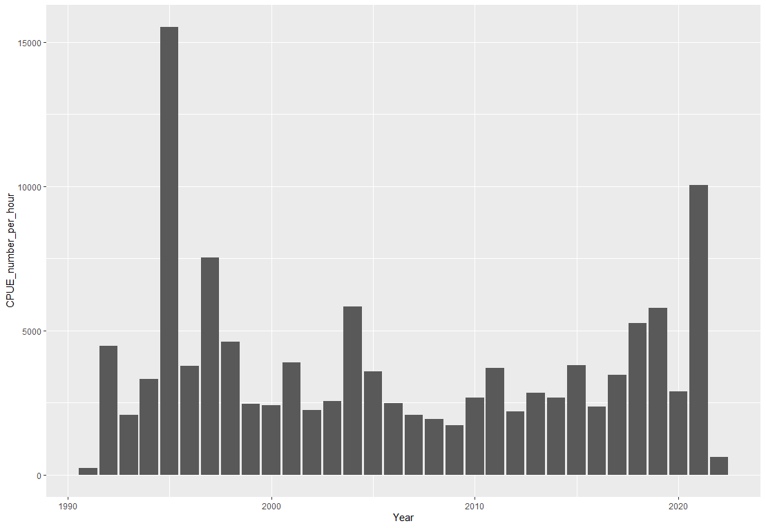

Fig.2 the bar chart shows the fluctuations of the CPUE per hour for WBC (western Baltic Cod) in a period of 32 years. this chart includes the catch per numbers of WBC in 3 quarters of the year in Area numbers 21,22,23 and 24 in the ICES data set map.

CPUE is an indirect indicator for measuring the abundance of WBC exploitation, therefore a high CPUE rate can show a high number of WBC, as we can see in the years 1995 and 2021. Also, a decreasing rate can translate into overexploitation as it appears in the years 1991 and 2022.

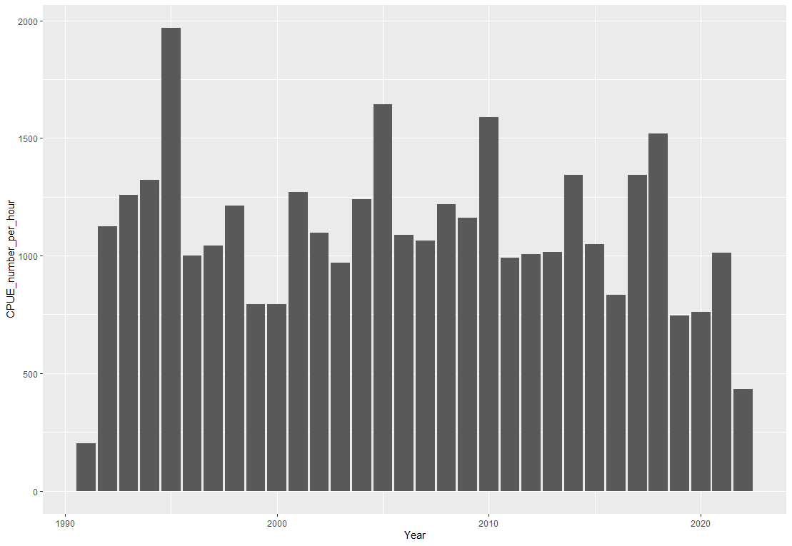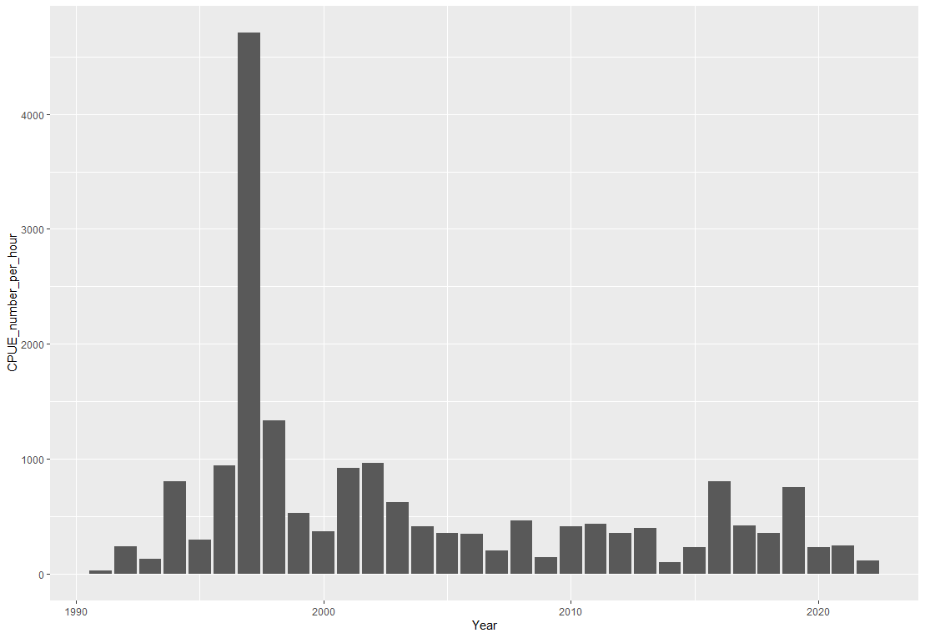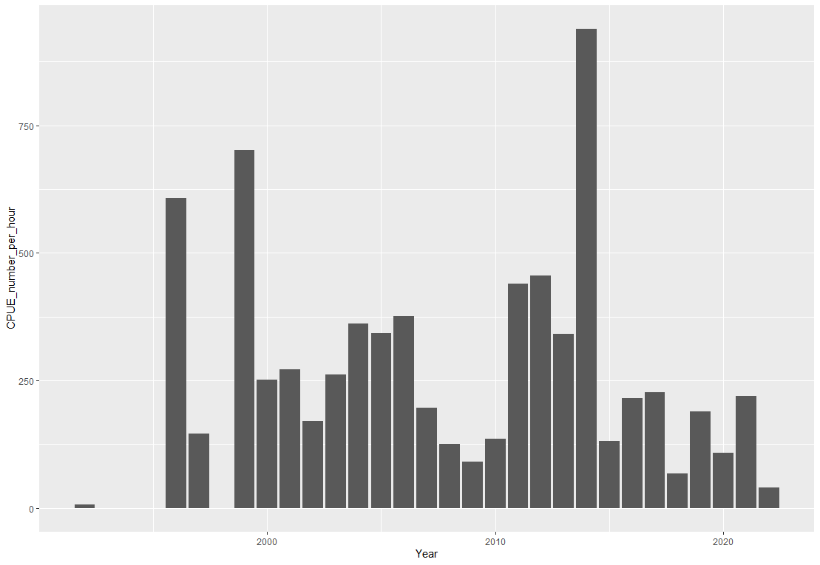

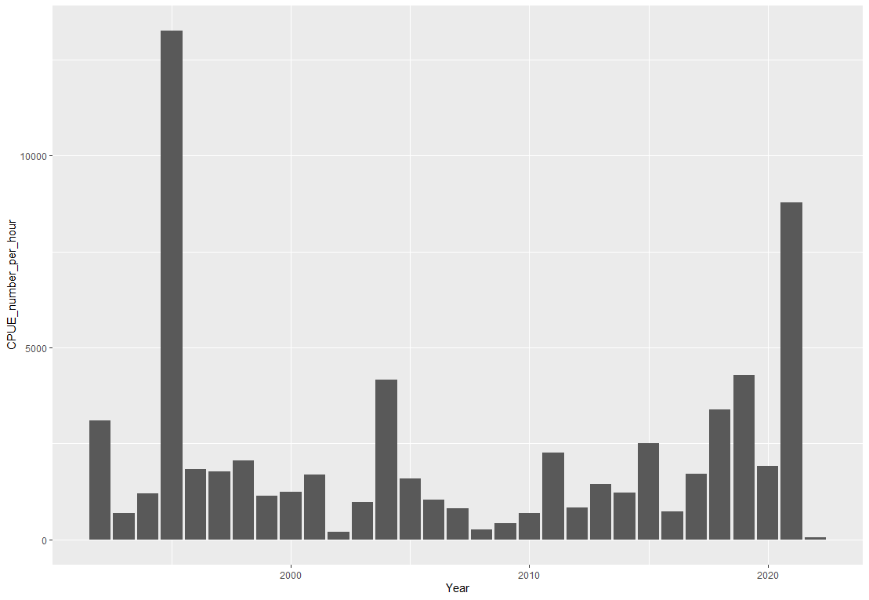 Area 21 Area 22

Area 23 Area 24

Fig.3 the WBC CPUE per hour rate divided by the Areas

a glance at the charts shows the high abundance of the WBC in Area 24 compared to the other areas, Area 24 experienced more sustainable exploitation. Area 22 also demonstrates almost sustainable exploitation except in the year 1997. Despite the declining rate in all areas, area 23 indicates the sharpest decrease compared to last year.

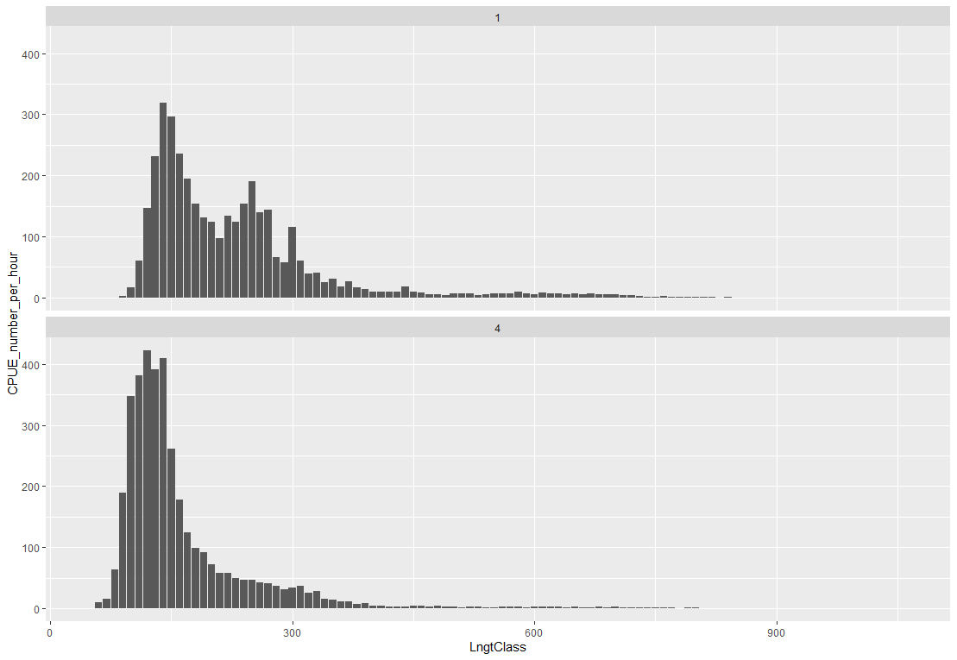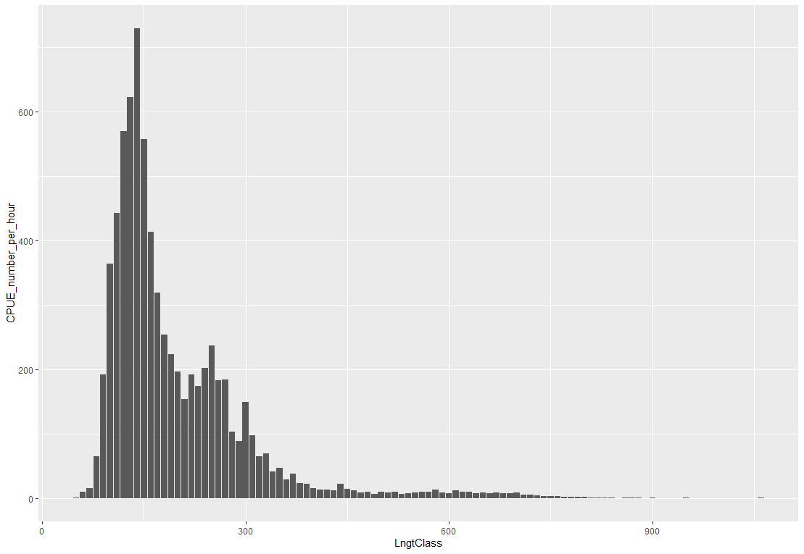

Fig.4 the CPUE per hour per length classes in area 21 in two quarters of the year. units for the length classes are in millimeters and for the CPUE measured as Catch in numbers per hour of hauling.

At first impression, the bigger WBC will face lower availability. Like many normal distribution graphs, the highest rate is expected in some certain length classes and after that, a downward trend existed as we can see in the 4th quarter. However, in the first quarter, the number of WBC catch varied in different length classes. Therefore, less exploitation in 3 different length classes can point to less interest in fishing or less availability.

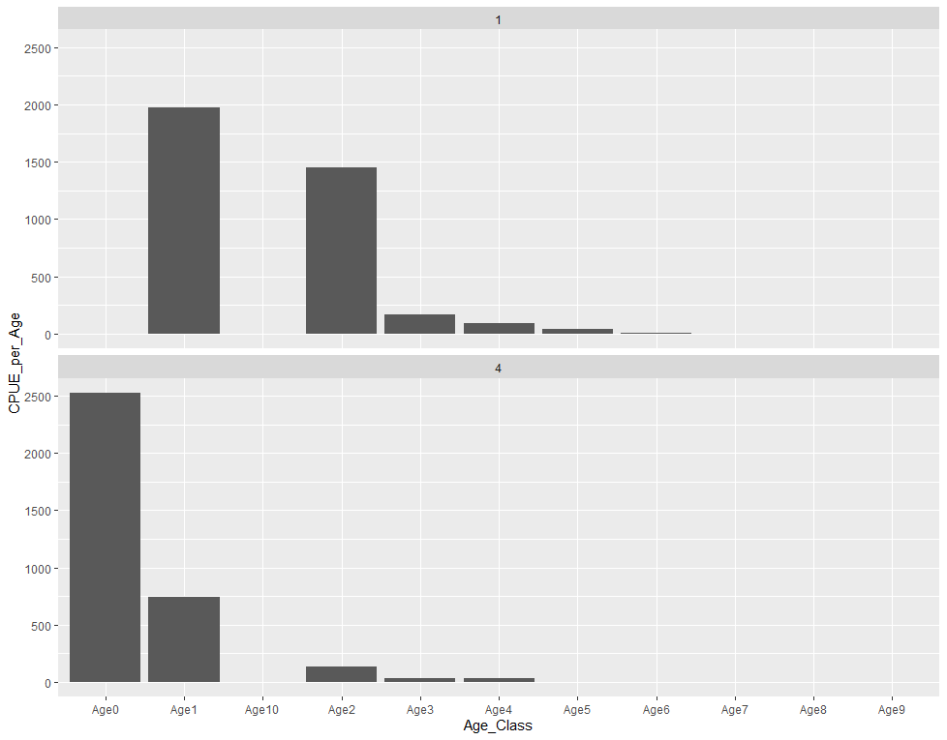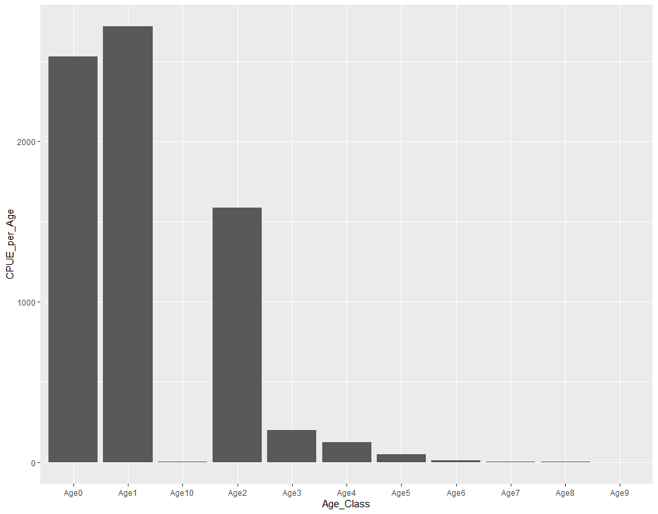

Fig.5 CPUE (Catch in numbers per hour) per age class in area 21 in two quarters of the year.

A decreasing trend in the survey can lead to lower availability in older WBC. In the first quarter, there is no observation for the first and 7th age classes, however, the highest rate is shown in the first age class. Also, there is no observation for the 5th age class in the 4th quarter of the year. These results can point out possible migrations and recruitments.

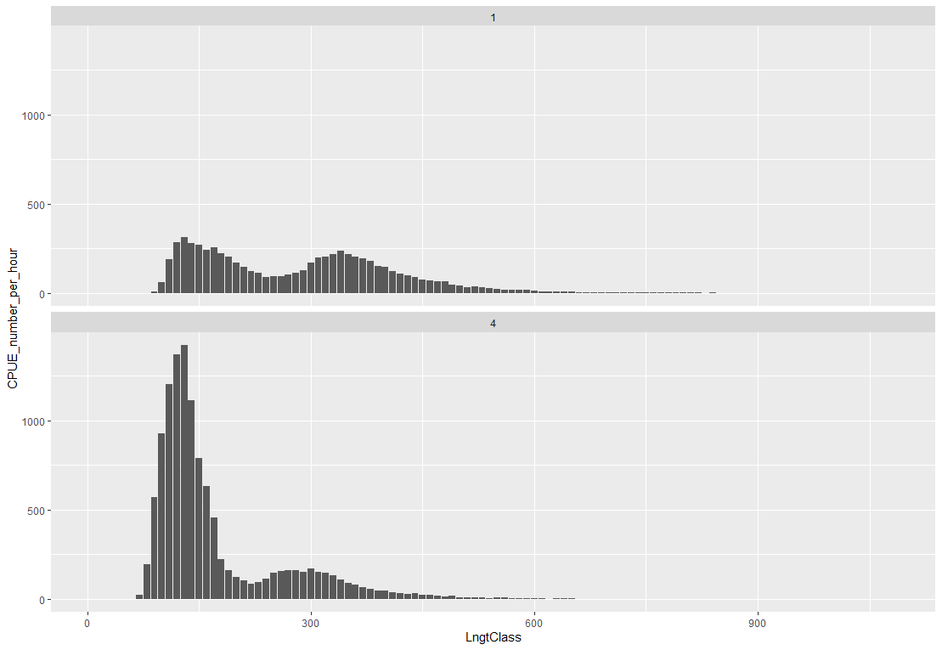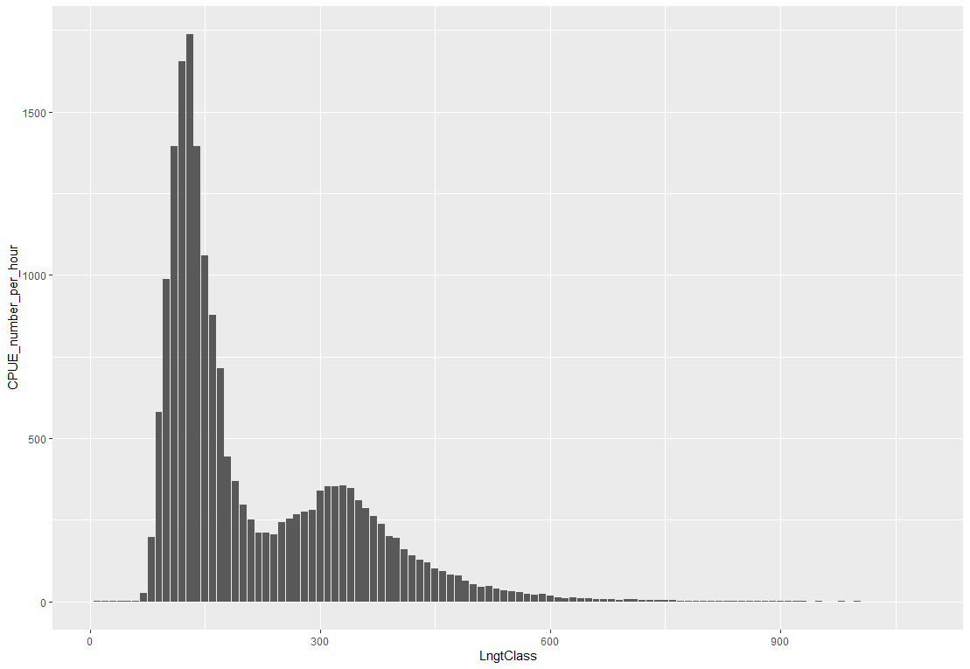

Fig.6 the CPUE per hour per length classes in area 22 in two quarters of the year. units for the length classes are in millimeters and for the CPUE measured as Catch in numbers per hour of hauling.

Results for this area are mostly similar to those in area 21 whit the exception of a difference in abundance in comparison to the first quarter in area 22.

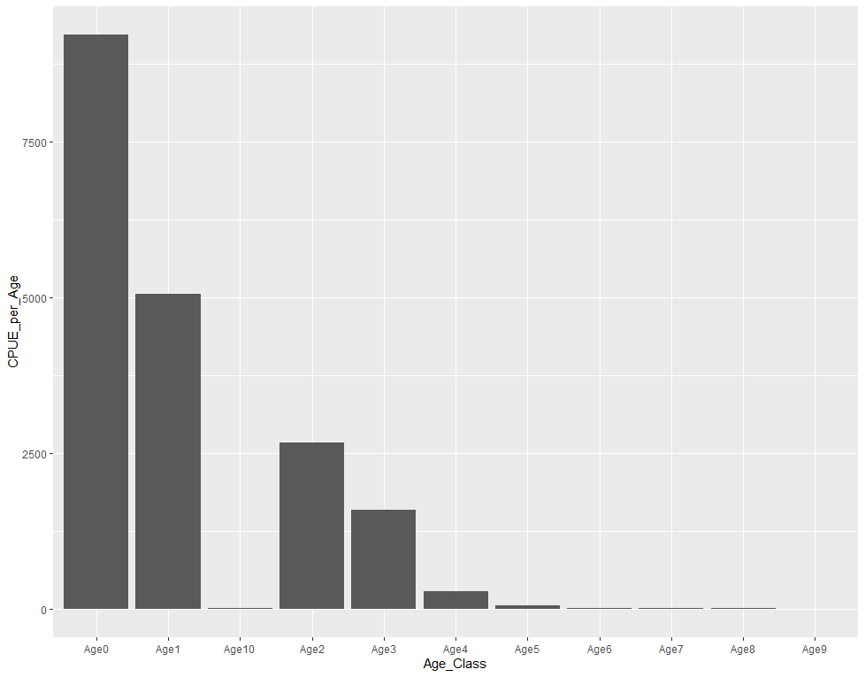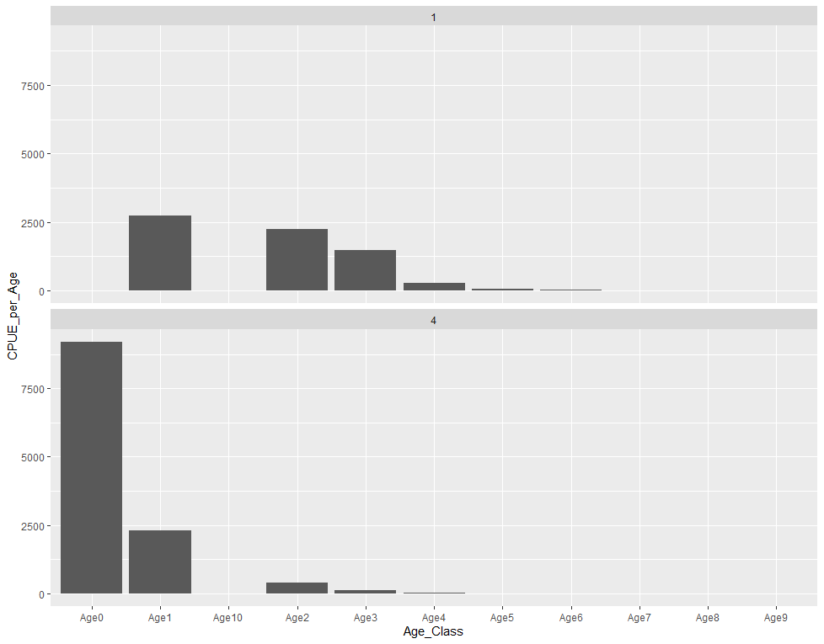

Fig.7 CPUE (Catch in numbers per hour) per age class in area 22 in two quarters of the year

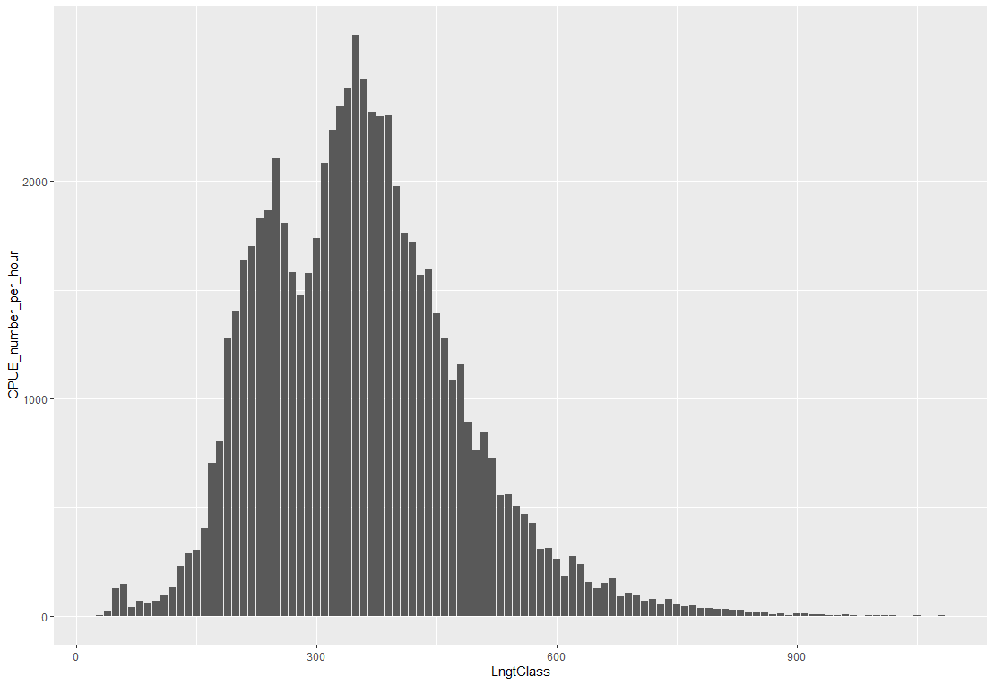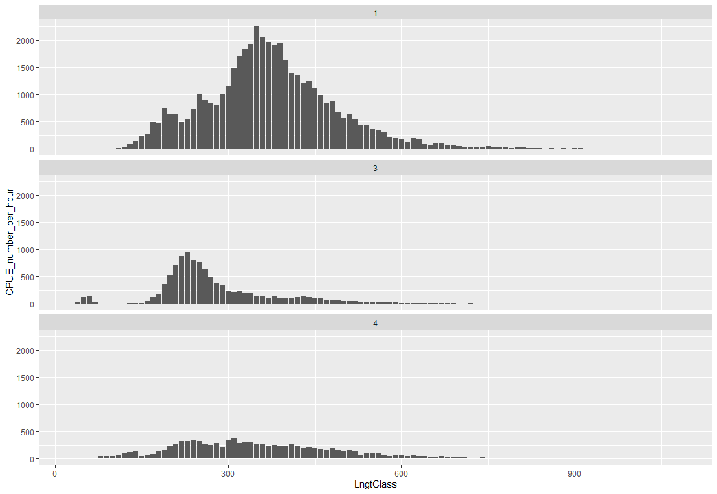Fig.8 includes CPUE per length class in Area 23 for 3 quarters of the year.

In this area, the main observations are in higher-length classes which demonstrates a higher abundance of large WBC. In comparison to the last areas, the main observations are in the first quarter and third quarter. These results can show area 23 as a possible migration destination during spring and fall.

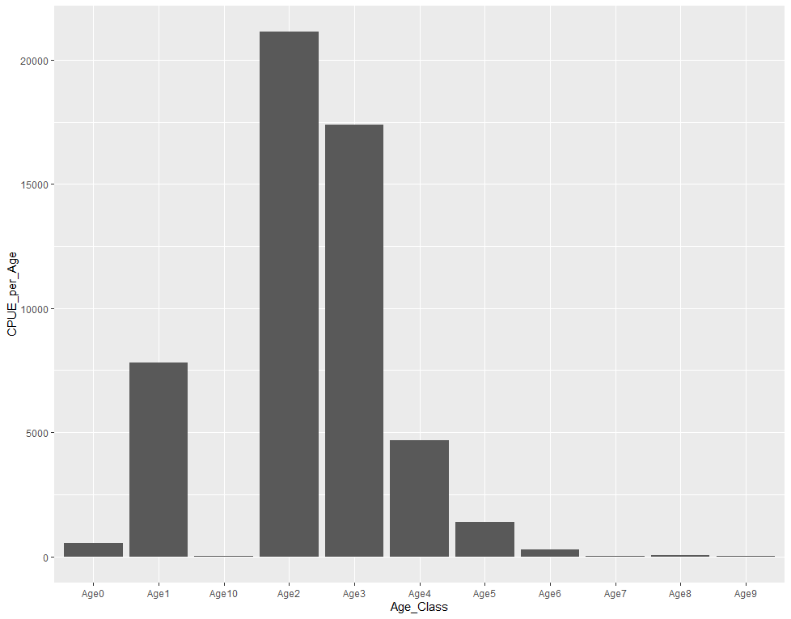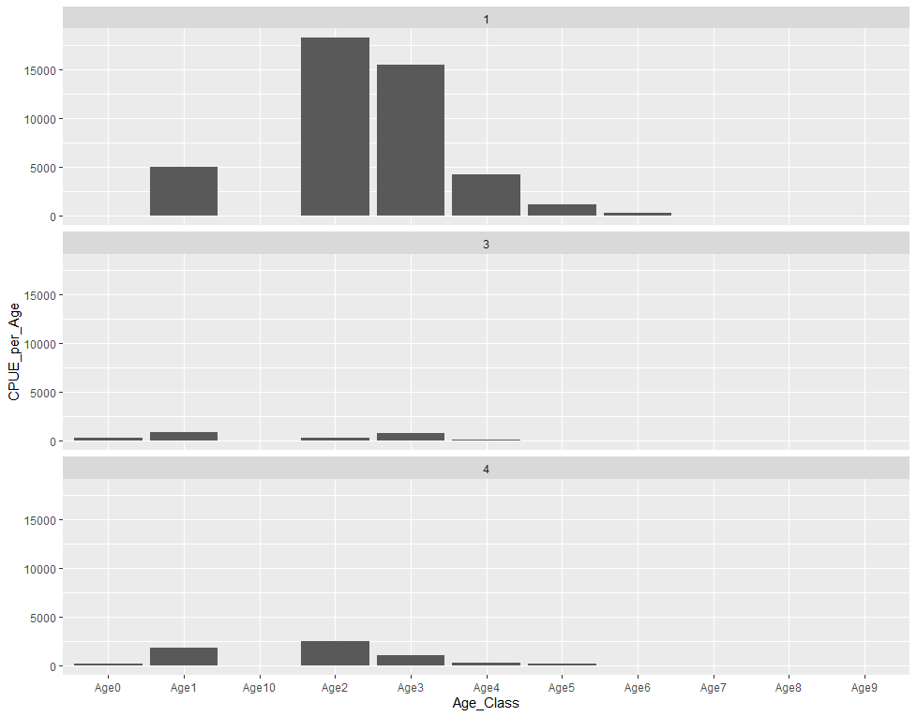

Fig.9 CPUE (Catch in numbers per hour) per age class in area 23 in 3 quarters of the year

The continuity of age and size can confirm the results mentioned in Fig.7. the highest abundance of observations in 2nd and 3rd age classes in the first quarter.

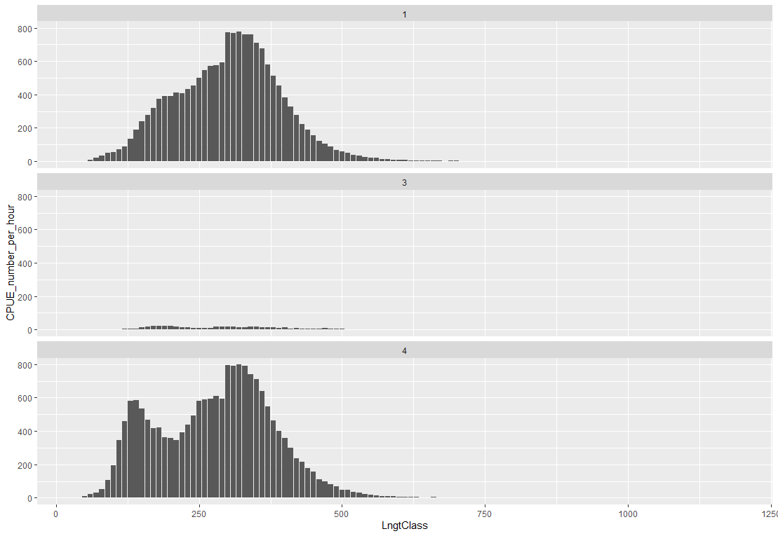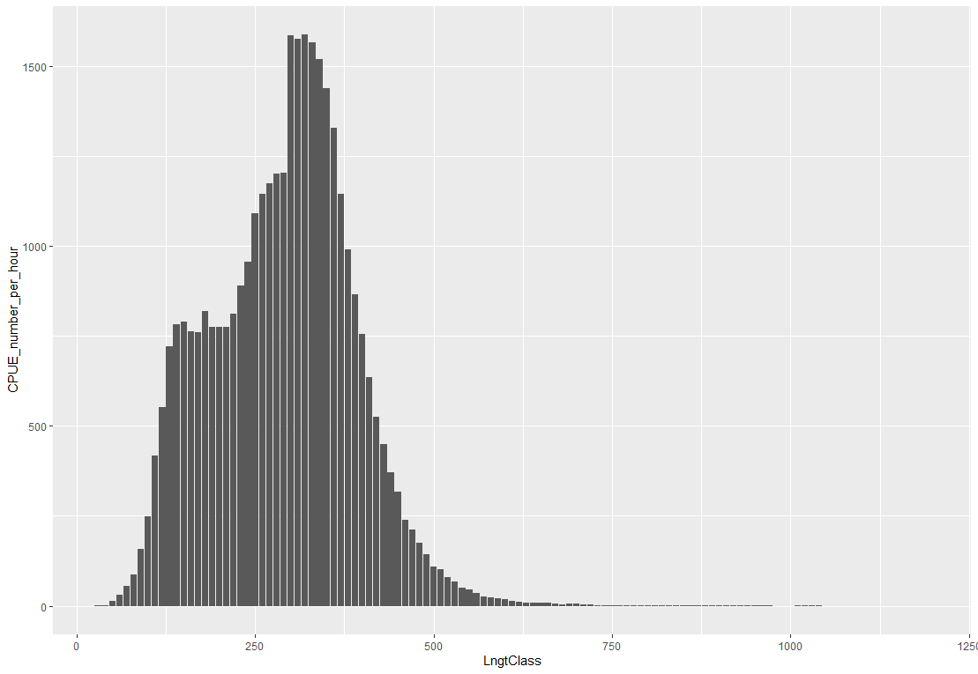Fig.10 includes the CPUE per length classes in area 24 in 3 quarters of the year. units for the length classes are in millimeters and for the CPUE measured as Catch in numbers per hour of hauling.

In comparison to the other areas, this area is similar to area 23 on a different scale. Area 24 experienced the highest abundance of WBC among the others. Also, the appearance of lower-length classes in this area can nominate this area as the nursing pool or spawning area for WBC.

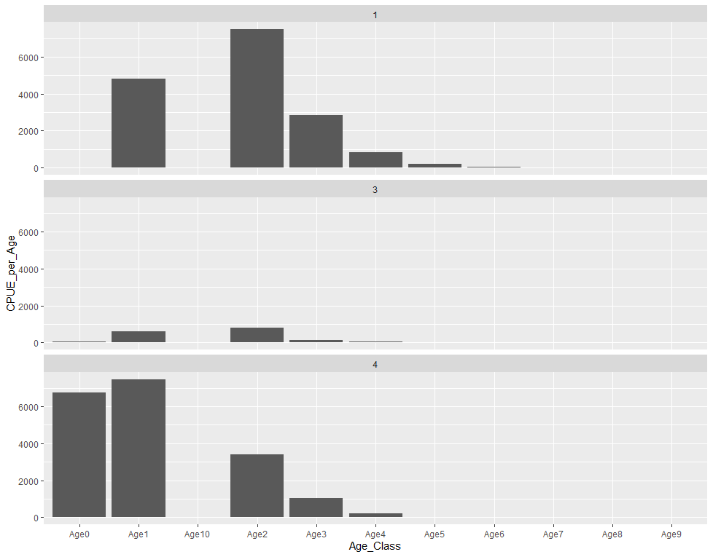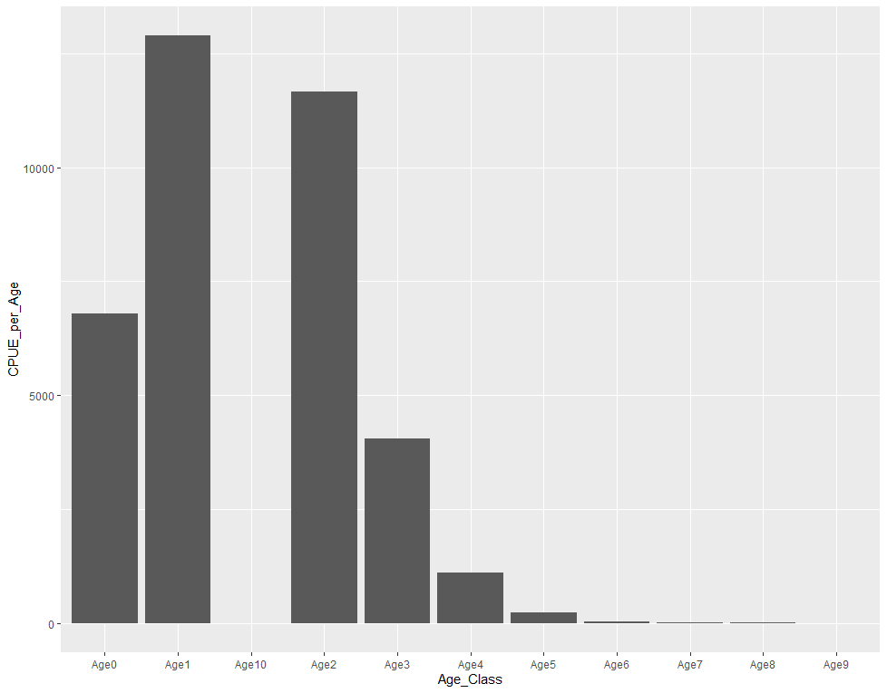

Fig.11 CPUE (Catch in numbers per hour) per age class in area 24 in 3 quarters of the year

A glance at the charts reveals the same results mentioned above in Fig.9. the highest abundance of observations in the first and 2nd age classes indicates the early ages of Growth in WBC in area 24.

Temperature

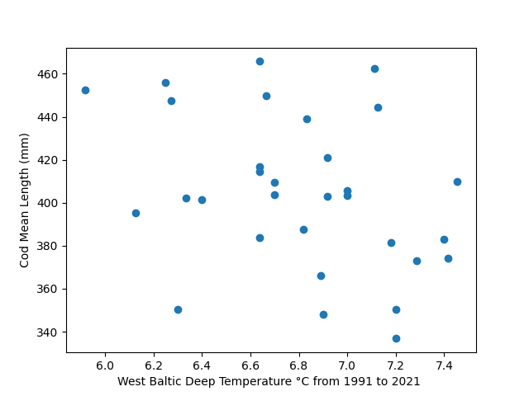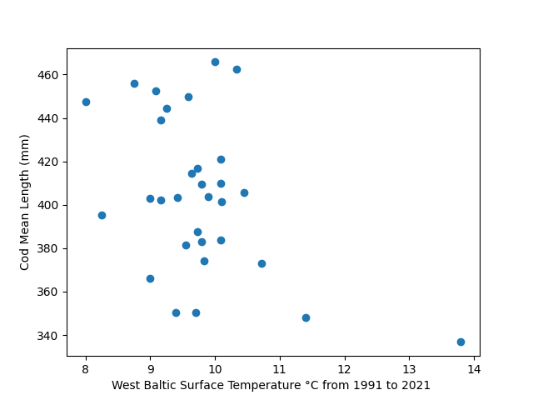

Fig12 scatter plots showing the relationship between temperature and Cod CPUE at the surface and in deep water (100 m)

Surface (Coefficient: -15.94853475110387, Intercept: 560.2225548119409)

Deep water (Coefficient: -31.542324725239308, Intercept: 618.9919587889099)

A negative coefficient represents the reverse relations between the temperature and mean length of WBC in both surface and deep-water temperature situations.

Surface Temperature

OLS Regression Results

==============================================================================

Dep. Variable: LngtClass R-squared: 0.204

Model: OLS Adj. R-squared: 0.177

Method: Least Squares F-statistic: 7.431

Date: Mon, 24 Apr 2023 Prob (F-statistic): 0.0108

Time: 15:11:27 Log-Likelihood: -150.72

No. Observations: 31 AIC: 305.4

Df Residuals: 29 BIC: 308.3

Df Model: 1

Covariance Type: nonrobust

===================================================================================

coef std err t P>|t| [0.025 0.975]

-----------------------------------------------------------------------------------

const 560.2226 57.439 9.753 0.000 442.746 677.699

STemperature °C -15.9485 5.850 -2.726 0.011 -27.914 -3.983

==============================================================================

Omnibus: 0.213 Durbin-Watson: 0.390

Prob(Omnibus): 0.899 Jarque-Bera (JB): 0.314

Skew: 0.174 Prob(JB): 0.855

Kurtosis: 2.651 Cond. No. 98.1

Deep water Temperature

OLS Regression Results

==============================================================================

Dep. Variable: LngtClass R-squared: 0.125

Model: OLS Adj. R-squared: 0.095

Method: Least Squares F-statistic: 4.143

Date: Mon, 24 Apr 2023 Prob (F-statistic): 0.0510

Time: 14:59:02 Log-Likelihood: -152.19

No. Observations: 31 AIC: 308.4

Df Residuals: 29 BIC: 311.2

Df Model: 1

Covariance Type: nonrobust

===================================================================================

coef std err t P>|t| [0.025 0.975]

-----------------------------------------------------------------------------------

const 618.9920 105.582 5.863 0.000 403.053 834.931

DTemperature °C -31.5423 15.497 -2.035 0.051 -63.236 0.152

==============================================================================

Omnibus: 0.055 Durbin-Watson: 0.451

Prob(Omnibus): 0.973 Jarque-Bera (JB): 0.267

Skew: -0.020 Prob(JB): 0.875

Kurtosis: 2.547 Cond. No. 121.

==============================================================================

Food availability

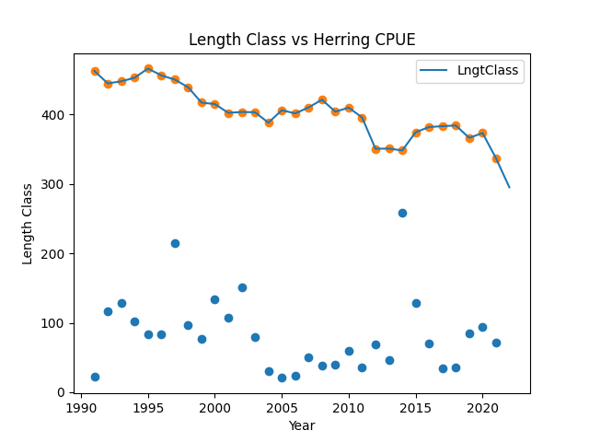

Fig.13 graph visualizing the relations between Herring CPUE (blue dots) and mean length of WBC.

Coefficient: 0.023316678862333868

Intercept: 402.4982092714058

OLS Regression Results

==============================================================================

Dep. Variable: LngtClass R-squared: 0.001

Model: OLS Adj. R-squared: -0.033

Method: Least Squares F-statistic: 0.03727

Date: Mon, 24 Apr 2023 Prob (F-statistic): 0.848

Time: 15:24:11 Log-Likelihood: -154.24

No. Observations: 31 AIC: 312.5

Df Residuals: 29 BIC: 315.3

Df Model: 1

Covariance Type: nonrobust

================================================================================

coef std err t P>|t| [0.025 0.975]

--------------------------------------------------------------------------------

const 402.4982 11.999 33.543 0.000 377.957 427.040

Herring CPUE 0.0233 0.121 0.193 0.848 -0.224 0.270

==============================================================================

Omnibus: 0.912 Durbin-Watson: 0.198

Prob(Omnibus): 0.634 Jarque-Bera (JB): 0.786

Skew: -0.031 Prob(JB): 0.675

Kurtosis: 2.223 Cond. No. 183.

==============================================================================

Cod stock density

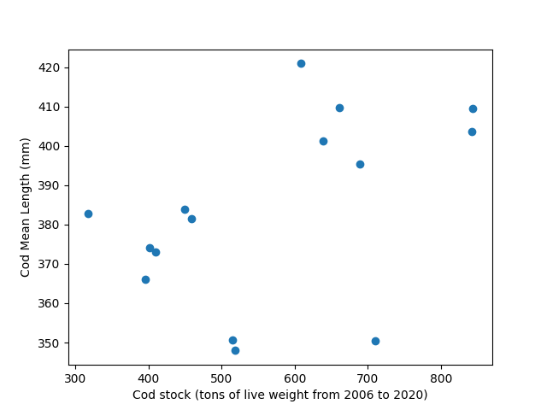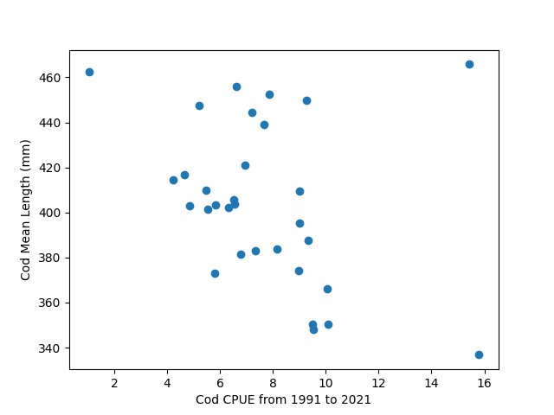

Fig.14 relationship between the increase of cod stock and the mean length(left).and also between Cod CPUE and Cod mean length.( Coefficient: 0.06560129071547326, Intercept: 346.3911907837698)

OLS Regression Results

==============================================================================

Dep. Variable: LngtClass R-squared: 0.214

Model: OLS Adj. R-squared: 0.154

Method: Least Squares F-statistic: 3.541

Date: Mon, 24 Apr 2023 Prob (F-statistic): 0.0824

Time: 15:20:39 Log-Likelihood: -66.170

No. Observations: 15 AIC: 136.3

Df Residuals: 13 BIC: 137.8

Df Model: 1

Covariance Type: nonrobust

==============================================================================

coef std err t P>|t| [0.025 0.975]

------------------------------------------------------------------------------

const 346.3912 20.422 16.961 0.000 302.271 390.511

stock size 0.0656 0.035 1.882 0.082 -0.010 0.141

==============================================================================

Omnibus: 2.111 Durbin-Watson: 0.882

Prob(Omnibus): 0.348 Jarque-Bera (JB): 1.163

Skew: -0.680 Prob(JB): 0.559

Kurtosis: 2.891 Cond. No. 2.16e+03

==============================================================================

Discussion

Concern has been for a while over the West Baltic Sea's declining cod catch per unit effort (CPUE). The morphological changes in Cod populations, like variations in mean length, may be one factor contributing to this loss. In this discussion, we'll look at how modifications to cod morphology may have contributed to the reported reduction in CPUE for cod in the western Baltic Sea.

Changes in Cod Mean Length: It has been suggested that changes in cod mean length might be the cause of the drop in the cod CPUE. A decline in the mean length of cod may indicate overfishing or a population that is not increasing as quickly as it should. The cod population may suffer as a result, as smaller cod may be more susceptible to predators and environmental pressures.

The link between the drop in Cod CPUE in the western Baltic Sea and Cod mean length has been the subject of several research. The fall in the Cod CPUE may be caused by a decrease in the mean length of the cod, according to several research that has discovered a substantial negative association between the two. For instance, research by Bartolino et al. (2015) discovered that a fall in cod mean length was the main factor contributing to the decline in the cod CPUE in the western Baltic Sea.

Other research, however, has not shown any connection between the reduction in the Cod CPUE and the mean length of the cod. For instance, Nielsen et al (2014) 's study discovered that variations in cod mean length were unable to account for the observed drop in the CPUE of cod in the western Baltic Sea.

The variations in the research designs, such as the sampling techniques or the time period examined, maybe the cause of the inconsistencies in the conclusions of these studies. In addition, other elements including variations in temperature, the availability of food, and the density of the cod stock may potentially be contributing to the observed reduction in the CPUE.

Temperature

It has been suggested that variations in temperature might also be contributing to the drop in Cod CPUE. The physiology and behavior of the cod, including their rates of development and migration, can be impacted by temperature changes. The availability of the Cod to fisheries may alter as a result of these modifications. Nevertheless, research looking at this aspect has also yielded contradictory findings, making it unclear how exactly temperature changes contributed to the reduction in the Cod CPUE.

Food Availability

It has been suggested that changes in food availability are a major factor behind the reduction in Cod CPUE in the western Baltic Sea. The number and distribution of prey species have both been connected to overfishing and climate change, which may have an influence on the feeding ecology and ultimately the survival of the cod. Furthermore, the dynamics of the food web and the availability of prey species for the cod can also be impacted by the introduction of non-native species to the Baltic Sea, such as the round goby. As a result, the fall of the Cod CPUE in the western Baltic Sea is probably significantly influenced by changes in food availability. (22_25)

However, we have seen no relation between the availability of Herring as a portion of live food for WBC and Cod CPUE.

Cod Stock Density

Lastly, it has been suggested that the drop in the CPUE for cod is significantly influenced by the density of the cod stock. Cod populations can become less numerous and smaller due to overfishing, which increases their susceptibility to predators and other environmental stresses. Further population losses can result from the elimination of big individuals since doing so lowers the population's total ability for reproduction and genetic diversity. Hence, it is likely that overfishing and the ensuing decrease in Cod stock density are at least largely to blame for the reduction in the CPUE for cod.

Conclusion

The fall in the Cod CPUE in the western Baltic Sea may be attributed to changes in the morphology of cod, such as variations in mean length. Nevertheless, given that investigations into this aspect have yielded conflicting findings, it is still unclear how the drop in the Cod CPUE is related to the average length of cod. Clarifying the significance of Cod morphology in the fall of the Cod CPUE and identifying additional potential causes of this loss requires more investigation. It will ultimately need a comprehensive strategy that takes into account the intricate connections between environmental variables, fishery management techniques, and modifications in Cod morphology to address the reduction in the Cod CPUE in the western Baltic Sea.

In summary, changes in the availability of food, the density of the cod stock, and maybe morphological and temperature changes are all likely contributing causes to the drop in the cod CPUE in the western Baltic Sea. The proportional importance of every element is still debatable and needs more research. It will ultimately need a comprehensive strategy that takes into account the intricate linkages between environmental variables and fisheries management approaches to solve the drop in the cod CPUE in the western Baltic Sea.

1. Biro, P. A., & Post, J. R. (2008). Rapid depletion of genotypes with fast growth and bold personality traits from harvested fish populations. Proceedings of the National Academy of Sciences, 105(8), 2919-2922.
2. Jørgensen, C., & Fiksen, Ø. (2010). State-dependent energy allocation in cod (Gadus morhua). Canadian Journal of Fisheries and Aquatic Sciences, 67(12), 1957-1966.
3. Law, R. (2000). Fishing, selection, and phenotypic evolution. ICES Journal of Marine Science, 57(3), 659-668.
4. Starr, P. J., & Hilborn, R. (2017). Selectivity and the shape of age and size distributions in exploited fish populations. Canadian Journal of Fisheries and Aquatic Sciences, 74(12), 2087-2099.
5. Casini, M., Blenckner, T., Möllmann, C., Gårdmark, A., Lindegren, M., Llope, M., ... & Folke, C. (2016). Hypoxic areas, density-dependence and food limitation drive the body condition of a heavily exploited marine fish predator. Royal Society open science, 3(1), 150489.
6. Eero, M., MacKenzie, B. R., Köster, F. W., Gislason, H., & Kjesbu, O. S. (2011). Baltic cod recruitment–the impact of climate variability on key processes. Ices Journal of Marine Science, 68(6), 1059-1068.
7. ICES. (2020). Report of the ICES advisory committee on fishery management, advisory committee on the marine environment and advisory committee on ecosystem. ICES Advice, 2020, cod. 22.2.1-11.
8. Pulkkinen, K., Suomalainen, L. R., Read, A. F., Ebert, D., & Rintamäki-Kinnunen, P. (2010). Intensive fish farming and the evolution of pathogen virulence: the case of columnaris disease in Finland. Proceedings of the Royal Society B: Biological Sciences, 277(1684), 593-600.
9. Lehmann, A., Hinrichsen, H. H., Getzlaff, K., & Köster, F. W. (2011). Decreased condition and high rates of atresia in Baltic cod, Gadus morhua, after a decade of declining stock abundance: a sensitive period hypothesis. Marine Ecology Progress Series, 426, 253-265.
10. Szymon Smoliński, Krzysztof Radtke, Spatial prediction of demersal fish diversity in the Baltic Sea: comparison of machine learning and regression-based techniques, ICES Journal of Marine Science, Volume 74, Issue 1, January-February 2017, Pages 102–111, https://doi.org/10.1093/icesjms/fsw136Brander, K. (2010). Effects of climate on cod (Gadus morhua) in the North Atlantic. ICES Journal of Marine Science, 67(5), 927-945.
11. Gjøsæter, H. (1984). Stock discrimination and morphometric variation of cod (Gadus morhua L.) from the Norwegian coast. Sarsia, 69(4), 297-307.
12. Rome, Lawrence C., Roel P. Funke, and R. McNeill Alexander. "The influence of temperature on muscle velocity and sustained performance in swimming carp." Journal of Experimental Biology 154.1 (1990): 163-178.Lindström, K., Lundqvist, H., & Nyman, L. (2007). Effects of temperature and oxygen conditions during incubation on egg and yolk-sac larvae of Atlantic cod, Gadus morhua. Marine Biology, 151(3), 1079-1087.
13. Brett, J. R., and T. D. D. Groves. "Physiological energetics." Fish physiology 8.6 (1979): 280-352.Corkett, C. J., Thurston, R. V., & Mellor, G. L. (1991). Effects of feeding on the growth and survival of larval and juvenile cod (Gadus morhua). Canadian Journal of Fisheries and Aquatic Sciences, 48(9), 1723-1733.
14. Gallagher, A. J., Franks, B. R., & Cooke, S. J. (2014). Negative effects of starvation on energetics and activity levels of juvenile Atlantic cod. Journal of Experimental Marine Biology and Ecology, 460, 62-69.
15. Rountrey, A. N., Coulson, P. G., Meeuwig, J. J., & Meekan, M. G. (2005). Skeletal deformation in presettlement and juvenile coral reef fish: a consequence of feeding habitat? Coral Reefs, 24(1), 127-131.
16. Neuenfeldt, S., Hinrichsen, H. H., & Köster, F. W. (2013). Environmental and density-dependent effects on the growth of cod (Gadus morhua) in the Baltic Sea. ICES Journal of Marine Science, 70(2), 331-339.
17. Ottersen, G., Planque, B., Belgrano, A., Post, E., Reid, P. C., & Stenseth, N. C. (2013). Ecological effects of the North Atlantic Oscillation. Oecologia, 172(1), 1-12.
18. Sparholt, H. (1990). Reproductive investment and optimal size in cod (Gadus morhua L.) in relation to fluctuations in stock size. Journal of Fish Biology, 37(supplement A), 123-136.
19. Neuenfeldt, S., Andersen, K. H., Hinrichsen, H. H., Huwer, B., Köster, F. W., Munk, P., ... & St. John, M. (2013). Recruitment of Baltic cod and sprat stocks: identification of critical life stages and incorporation of environmental variability into stock-recruitment relationships. Progress in Oceanography, 114, 23-53.
20. MacKenzie, B. R., Alheit, J., Conley, D. J., Holm, P., Kinze, C. C., Osterblom, H., ... & Winder, M. (2012). Ecological hypotheses for a historical reconstruction of upper trophic level biomass in the Baltic Sea and Skagerrak. ICES Journal of Marine Science, 69(8), 1403-1416.
21. Lindegren, M., Neuenfeldt, S., Möllmann, C., & Voss, R. (2013). The trophic ecology of Baltic cod (Gadus morhua) during the early life stages. ICES Journal of Marine Science, 70(1), 26-36.
22. Eero, M., Hjelm, J., Behrens, J., Buchmann, K., Cardinale, M., Casini, M., ... & Köster, F. W. (2015). Eastern Baltic cod in distress: biological changes and challenges for stock assessment. ICES Journal of Marine Science, 72(8), 2180-2186.